SERVICE REQUEST |  | On-site tests of fasteners
Hilti Corporation | Hilti (Aust.) Pty Ltd | T 131292 | W www.hilti.com.au
 | Level 5, 1G Homebush Bay Drive, Rhodes, NSW 2138 | F +61 2 8748 1190

On-site test order no.: Date of on-site test:

Customer Structural Engineer

Company: Company:

Address: Address:

Customer no.: Customer no.:

Contact name: Contact name:

Contact job title: Contact job title:

Phone: Phone:

E-mail: E-mail:

Site Phase of construction project Submission

Name / designation: Execution

Location / address:

Purpose and method of on-site test

Determination of the general suitability of the base material to secure fastenings for a customer-defined application on a specific project:

Pull-out test according to ETAG 029 Annex B.3.2.

Pull-out test according to ETAG 020 Annex B Test specimen [pc] =

Pull-out test according to ETAG 014

Pull-out test according to BS 8539 Annex B.2.3.2.

Proof-load test according to ETAG 029 Annex B.3.3. Proof load [kN] =

Proof-load test according to BS 8539 Annex B.2.3.2. Test specimen [pc] =

Quality control testing to identify grossly-misinstalled fastenings:

Proof-test according to BS 8539 9.3 and Annex B.3. Test load [kN] = Test specimen [pc] =

Acceptance test according to TRDB 3.2. / (3.3.) / 4. Load duration [min] = Allowable displacement [mm] =

Type of test

Unconfined test (supports widely spaced) Confined test (supports closely spaced)

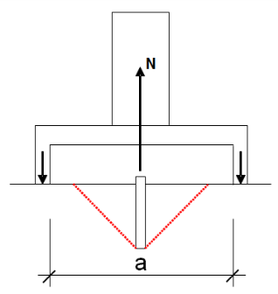
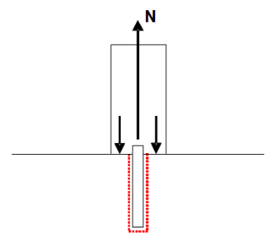
Testing: Testing:

Fastener failure Fastener failure
Pull-out Pull-out
Break-out
Cracking

a [mm] =

Measurement of displacement Test with measurement of displacement

Test without measurement of displacement

Important Information
General

On-site tests of fasteners do not: evaluate suitability or adequacy of the fastener design; verify proper installation or compliance with approval requirements; establish ultimate capacity of tested fasteners (unless tested to failure); or address performance of untested fasteners. Testing is performed as a service by Hilti in support of its products, and is intended solely to provide information on the general suitability of the base material and/or assist in identification of gross installation errors of tested fasteners – it does not imply any agreement in or endorsement of the suitability or propriety of the test or the application, and is not intended for use in satisfying any project or regulatory requirements for on-site inspection.

Refer to the Hilti Fastening Technology Manual for information on fastener design and performance. Proper installation of fasteners is critical – training is available on request – contact Hilti for information.
Execution of on-site tests

Test results only indicate the tested anchor(s) held the stated load for the time applied respectively the applicable failure load values.

The location and number of tests as well as the loading parameters and the fasteners to be tested will be carried out as determined by Customer and set out in this Service Request. Customer confirms that the testing conditions set out in this Service Request are correct. Hilti does not assess whether these test conditions are suitable for evaluation. The Customer or a Customer representative is required to participate, witness and supervise the execution of the tests.

Due to the possible variability of the base material and the various loading situations, the test results may not be representative of the entire construction project.

On-site tests may damage the structure - Hilti is not responsible for the damage, or its restoration.

For Hilti to be able to carry out onsite-tests of fasteners, Customer must ensure that:
- There must be at least one anchor diameter of clean thread standing out to attach the testing equipment to it.
- The area around the fasteners to be tested (at least 10 in circle) shall be unobstructed.
- Platform shall be provided for fasteners installed out of reach or overhead.
- Work area shall be easily accessible and safe to work on.

Evaluation of on-site tests

Any calculation or assessment by Hilti is based solely on the test results and performed according to the indicated calculation standard.
It is the Customer’s sole responsibility to determine whether the test data, calculation, assessment, and design standard are suitable and adequate for their specific jurisdiction and project.

Hilti Terms and Conditions of Sale

The Hilti Terms and Conditions of Sale, current at the time of Customer’s signature of this Request Form and available at www.hilti.com.au apply to the exclusion of any of Customer’s general business terms and conditions or general contractual terms.

I have read and understood the Important Information set out above and agree to the Hilti Terms and Conditions of Sale.

Name (print):_________________________ Company:_______________________________

Signature:____________________________ Date:___________________________________

